Q1.
Answer is C.

A: Valid but need to provide values for all columns in the table in the exact order.
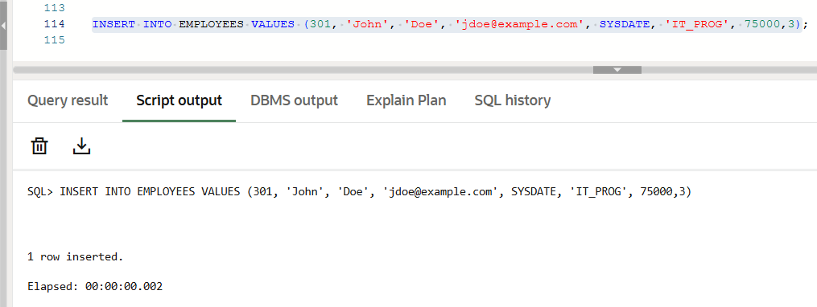

B: Invalid Syntax.
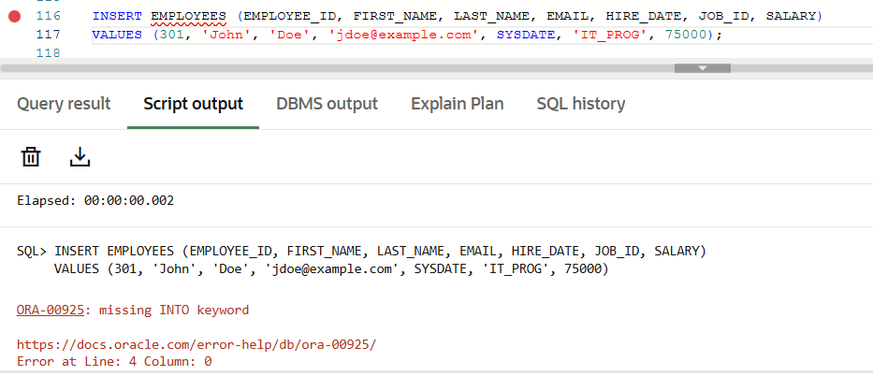

C: Correct and preferred
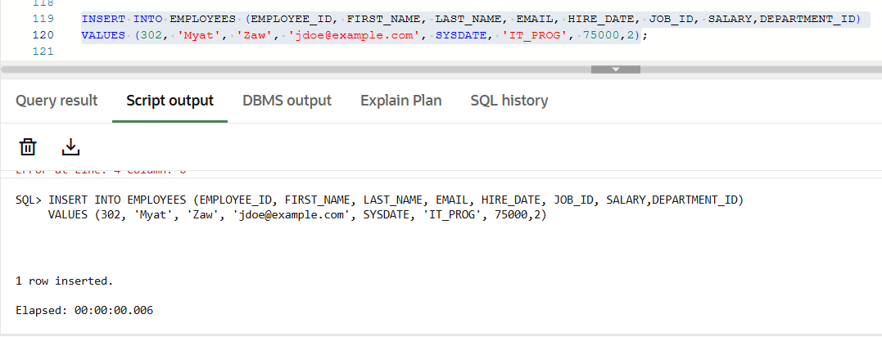

D: Invalid Syntax.
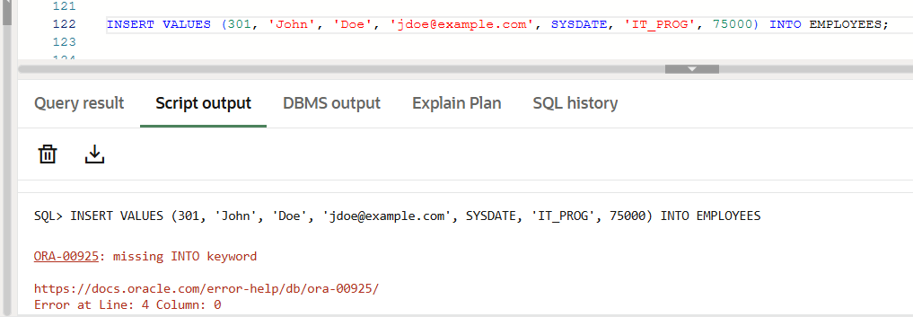

Q2.
Answer is A.

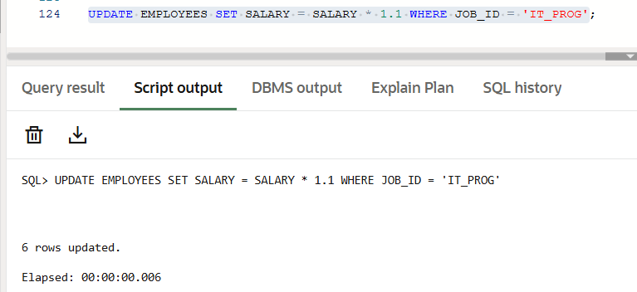

A: Syntax is standard SQL and works in Oracle, MySQL, SQL Server.

B: Invalid in Oracle SQL.

C: Invalid syntax.

D: Invalid.

Q3.
Answer is B.

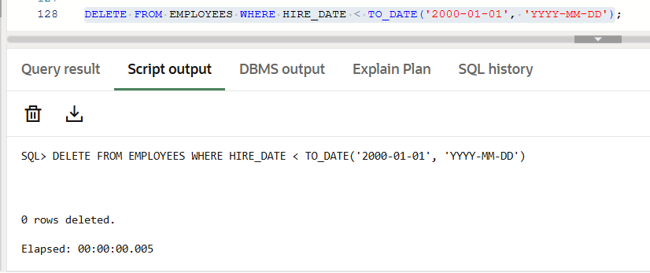

A: Incorrect. DELETE must be followed by FROM in Oracle SQL.

B: Correct. Deletes only employees hired before 2000.

C: Incorrect. REMOVE is not a valid SQL command.

D: Incorrect. DELETE does not use *; that syntax is invalid in SQL.

Q4.
Answer is A.

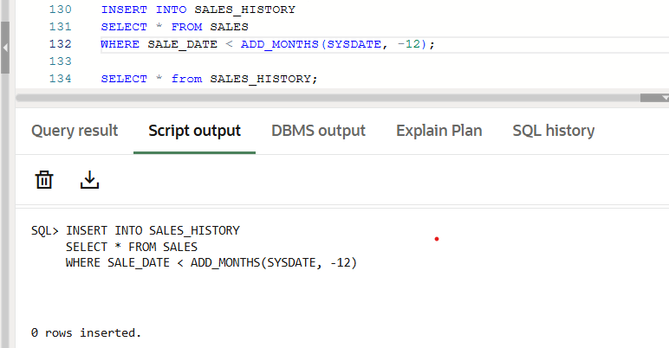

A: Correct. Work in Oracle.

B: Incorrect syntax.

C: Invalid.

D: Invalid.

Q5.
Answer is C.

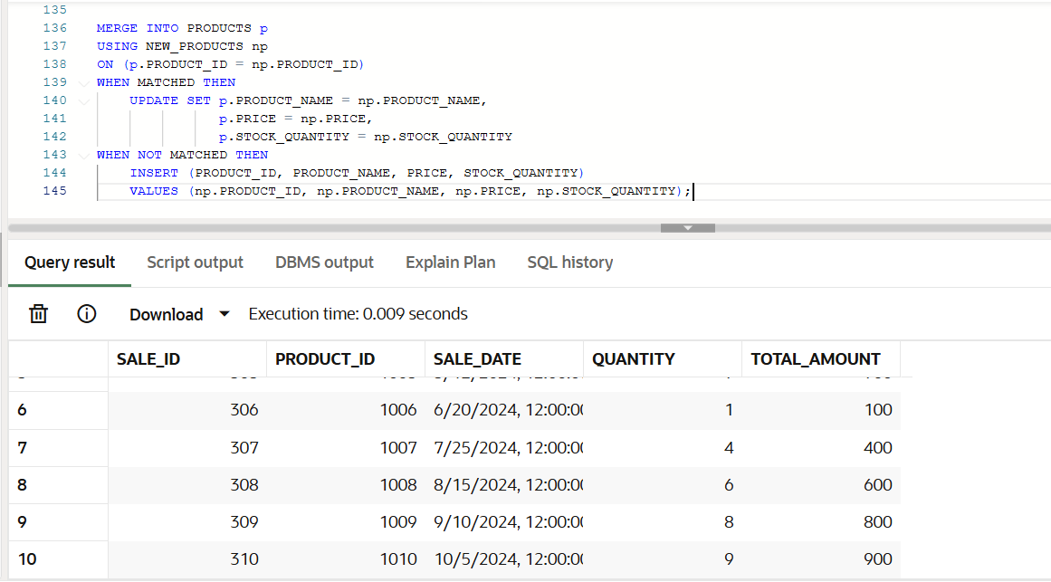

A: Not ideal for this task. This only updates existing products.

B: This inserts new products only.It does not update existing products that already exist in PRODUCTS.

C: Correct and efficient in Oracle SQL.

D: Invalid syntax in Oracle SQL.

Q6.
Answer is A.

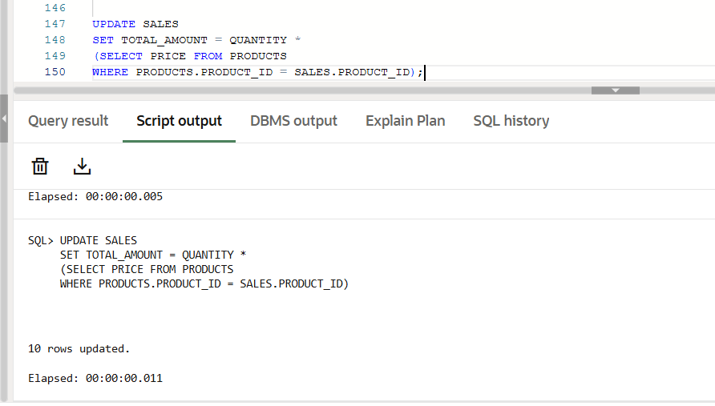

A: Correct. This is standard Oracle SQL syntax.

B: Invalid in Oracle SQL. Oracle does not allow UPDATE ... FROM syntax.

C: This works in Oracle and achieves the same result using a MERGE statement.

D: Invalid in Oracle SQL.

Q7.
Answer is A.

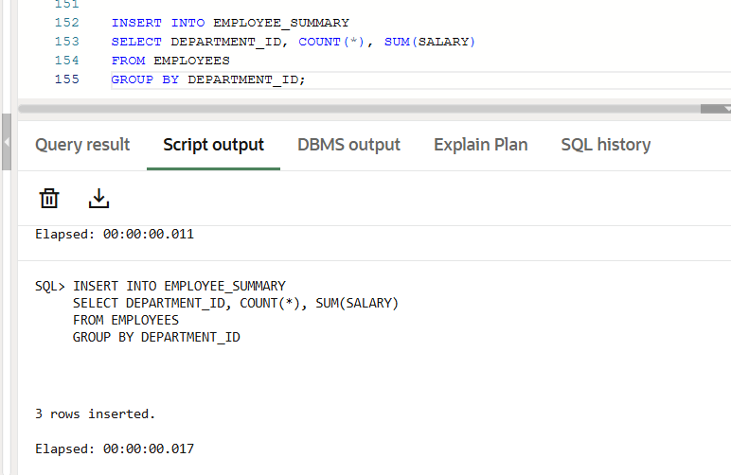

A: Correct and simplest solution.

B: Incorrect syntax.

C: Valid but complex.

D: Incorrect. UPDATE is not for inserting new rows—it only modifies existing rows.

Q8.
Answer is A.

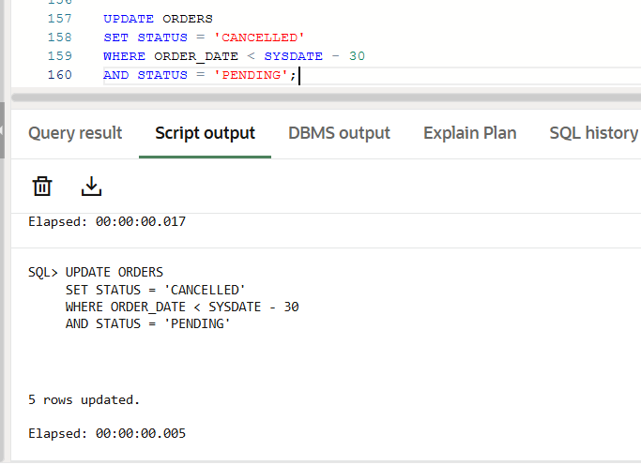

A: This is the simplest and most direct Oracle-compatible syntax.

B: Incorrect. DATEDIFF() is a MySQL function, not available in Oracle SQL.

C: Technically Correct, but Overcomplicated.

D: Also Correct but Less Efficient.

